Research Article / Review Articlee

TITLE TITLE TITLE TITLE TITLE TITLE TITLE TITLE TITLE TIMES NEW ROMAN 12, BOLD, CENTERED

FULL NAME OF THE AUTHOR/S¹, Mihai POPESCU²*, Aurora IONESCU³
TIMES NEW ROMAN 10, CENTERED, The names should not be abbreviated

Affiliation, Address of Institution, City – Country. Times New Roman, 9 points
2 Affiliation, Address of Institution, City – Country. Times New Roman, 9 points
3 Affiliation, Address of Institution, City – Country. Times New Roman, 9 points
*Corresponding author. E-mail: corresponding author@jpd.ro, ORCID:………

Abstract: A concise and factual abstract is required. The abstract should state briefly the purpose of the research, the principal results and major conclusions. An abstract is often presented separately from the article, so it must be able to stand alone. References should therefore be avoided in the abstract. Non-standard or uncommon abbreviations should be avoided but, if essential, they should be defined at their first mention in the abstract itself. Times New Roman, 8 points, Justify. Paragraph Hanging 1.5 cm.

Keywords: key word, key word, key word. Times New Roman, 8 points. Hanging 1.5 cm. At least 5 key words, in alphabetical order, and avoid overlapping keywords in your title.

Introduction

Times New Roman, 10 points, Justify. The main text would be written at a single space, Times New Roman, of 10 points. The text should be justified to occupy the full line width, so that the right margin is not ragged. Please fill pages so that the length of the text in page is no less than 180 mm, if possible.
We recommend an even number for total pages of manuscript.
The scientific names of plant species would be italicized (Zea mays). Tables should be numbered consecutively in accordance with their appearance in the text and given suitable captions; each table should begin on a new page. Be sparing in the use of tables and ensure that the data presented in tables do not duplicate results described elsewhere in the article.
Illustrations: photographs, charts and diagrams are all to be referred to as “Figure(s)”, should be numbered consecutively in accordance with their appearance in the text. The mentions at the drawings, figures, pictures and tables will be placed inside the round brackets – for instance (Figure nn, a-z, Figures m-n); (Table nn); all illustrations should be clearly marked with the figure number and the author’s name.
Obs.: all the schemes, drawings, etc. would be accompanied by a scale; the pictures must be very clear, being accompanied by the explanations. The diagrams should be made in Excel; pictures, ink drawings must be saved in JPG, JPEG, or BMP format, having a good resolution.
All publications cited in the text should be presented in a list of references following the text of the manuscript. In the text, references are made using the author (s) name of a certain paper (e.g.: other authors [GÉHU, 2006] mentioned that…). The full reference should be given in a numerical list in the end of the paper. References should be given inside the square brackets.
Material and methods

Times New Roman, 10 points, Justify. Materials and methods should be complete enough to allow experiments to be reproduced. However, only truly new procedures should be described in detail; previously published procedures should be cited, and important modifications of published procedures should be mentioned briefly. Methods in general use need not be described in detail.

Results and discussions

Times New Roman, 10 points, Justify. Results should be presented with clarity and precision. The results should be written in the past tense when describing findings in the authors' experiments. Previously published findings should be written in the present tense. Results should be explained, but largely without referring to the literature. Discussion and detailed interpretation of data should not be included in the Results but should be put into the Discussion section. The Discussions should interpret the findings in view of the results obtained in this and in past studies on this topic. State the conclusions in a few sentences at the end of the paper. The Results and Discussion sections can include subheadings, and when appropriate, both sections can be combined.
Obtain permission and include the acknowledgement required by the copyright holder if a table is being reproduced from another source.

Table nn. Table caption should always be positioned above the tables. Times New Roman, 9, centered.
Text Times New Roman, Bold, 9 points |  | Text Times New Roman, Bold, 9 points
Text | Lines – ½ pt | Times New Roman, 9 points | text
Text | text | text | text
Text | text |  | text
maximum width - 13 cm

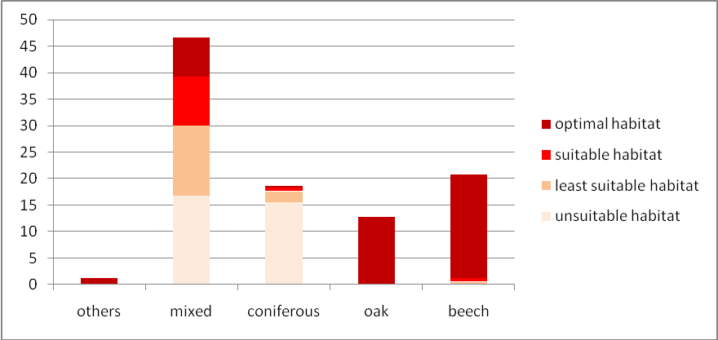

Figure nn. Figure caption should always be positioned after the figure. Times New Roman, 9, centered.

Conclusions

Times New Roman, 10 points, Justify. Conclusions should spell out the major findings of the work and may include some explanation of the significance of these conclusions and what further research should be done. Authors should include a general interpretation of the results in the context of current evidence, and not restricted to that which supports the findings of the present study.
Papers not complying with the JPD style will be reformatted. This can lead to an increase in the overall number of pages.

Acknowledgements
Times New Roman, 9 points, Justify. The Acknowledgments of people, grants, funds, etc. should be brief. People who contributed to the work but do not fit criteria for authorship should be listed in the Acknowledgments, along with their contributions. It is the authors’ responsibility to ensure that anyone named in the acknowledgments agrees to being so named.

References

Bailey J. P., Child L. E. & Conolly A. P. 1996. A survey of the distribution of Fallopia x bohemica in the British Isles. Watsonia. 21: 187-198. Alphabetical order, Times New Roman, 8 points, Hanging 1.27 cm. Please provide the DOI number of the titles in the format: https://doi.org/10.47743/jpd.2021.28.1.nn
Baldwin B. G., Goldman D. H., Keil D. J., Patterson R. W., Rosatti T. J. & Wilken D. H. 2012. The Jepson Manual: Vascular Plants of California. 2nd ed. Berkeley, Los Angeles, London: University of California Press, 1568 pp.
BOSCAIU N. 1971. Flora si Vegetatia Muntilor Tarcu si Cernei. Bucuresti: Edit. Academiei Române, 494 pp.
BOSCAIU N. 2001. Ecotonul si importanta functiilor sale ecoprotective [in Romanian]. Ocrotirea Naturii. 42: 13-21.
DJUIKOUO K. M. N. & ROBBRECHT E. 2008. Calycosiphonia pentamera sp. nov. (afrotropical Rubiaceae) from the ‘Lower Guinea’ area. Nordic Journal of Botany. https://doi.org/10.1111/j.0107-055X.2007.00141.x
HILLIER J. & COOMBES A. 2004. The Hillier Manual of Trees & Shrubs. Newton Abbot, Devon, England: David & Charles, 512 pp.
MEHREGAN I. & KADEREIT J. W. 2008. Taxonomic revision of sect. Cynaroideae (Asteraceae, Cardueae). Willdenowia. 38(2): 293-362.
NTORE S. 2004. Contribution à la connaissance systématique du genre afrotropical Pauridiantha (Rubiaceae). PhD thesis, K. U. Leuven, Leuven, Belgium.
QUINION M. B. 1998. Citing online sources: advice on online citation formats [online]. Available from www.worldwidewords.org/articles/citation.htm [accessed 20 Oct. 2021].
TUTIN T. G. 1996. Helleborus L. pp. 249-251. In: TUTIN T. G. & al. (eds.). 1996. Flora Europaea. 2nd ed.., 1993, reprinted 1996. Vol. 1. Psilotaceae to Platanaceae. Cambridge: Cambridge University Press, 581 pp.

How to cite this article:
TONIUC A. & DĂNĂLACHE B. 2025. Histo-anatomical data concerning some evergreen angiosperms – Editorial editing space. J. Plant Develop. 32: ◻◻–◻◻. https://doi.org/10.47743/jpd.2025.32.1.nn

